Background and Question Posed by Michigan
Michigan is seeking to have colorectal cancer screening made a quality measure by the state Medicaid office, as it has 150,000 members on the ACA Medicaid plan. Which states have made CRC screening as a quality measure?

Information from the NCCRT
Tracking CRC rates for Medicaid programs is not a national requirement and there is not currently a national compilation of all the states that have made CRC screening a quality measure. There is NHIS data on the national CRC screening rate for Medicaid patients; however, there is not a state-by-state comparison of Medicaid CRC screening rates.

According to 2013 NHIS data, only 36% of Medicaid-insured adults were up to-date with USPSTF CRC screening recommendations compared with at least 60% of privately or Medicare-insured adults.

The National Colorectal Cancer Roundtable (NCCRT) is working on publishing a study on state Medicaid programs that have included colorectal cancer screening as a quality measure. States with self-imposed requirements do have more robust colorectal cancer control efforts for their Medicaid programs. These include: Oregon, Maryland, New York, and Washington State.

Oregon Medicaid 2014 Statistics
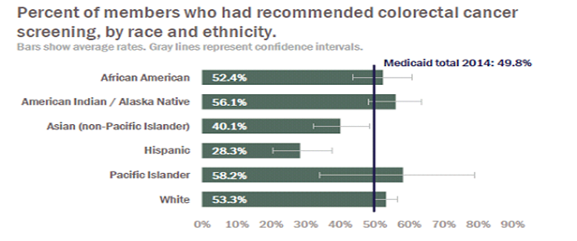

Maryland
Below are statistics for Medicaid screening rates for the past two fiscal years (July 1 - June 30). The data includes up-to-date screenings by colonoscopy, flex sigmoidoscopy, and FOBT. These rates are calculated based on Medicaid claims data.

Medicaid Ages 51-64
FY09: 32%
FY10: 34%
FY11: 33%
FY12: 32%
FY13: 31%
FY14: data has been received but is still being analyzed.

Maryland Colorectal Screening Cancer Rates
“In Maryland, colorectal cancer is the third most commonly- diagnosed cancer among both women and men, as well as the second-leading cause of cancer mortality. The expansion of Medicaid coverage to childless adults and additional parents and caretakers has removed a major access barrier for age-eligible low-income adults to be screened for colorectal cancer.”

Percentage of HealthChoice Participants Aged 50 – 64 Years Receiving a Screening for Colorectal Cancer, CY 2010–CY 2014

CY 2010 | CY 2011 | CY 2012 | CY 2013 | CY 2014
39.5% | 39.3% | 38.8% | 38.7% | 32.1%

“[This table] shows the percentage of HealthChoice participants who received at least one of the three appropriate screenings for colorectal cancer in CY 2010 through CY 2014…. Only participants who met the HEDIS eligibility requirements were included in the population for this measure. These participants were continuously enrolled in Medicaid during the calendar year and the preceding calendar year.”

Maryland Colorectal Cancer Screening Rates for Medicaid Enrollees 2011-2013
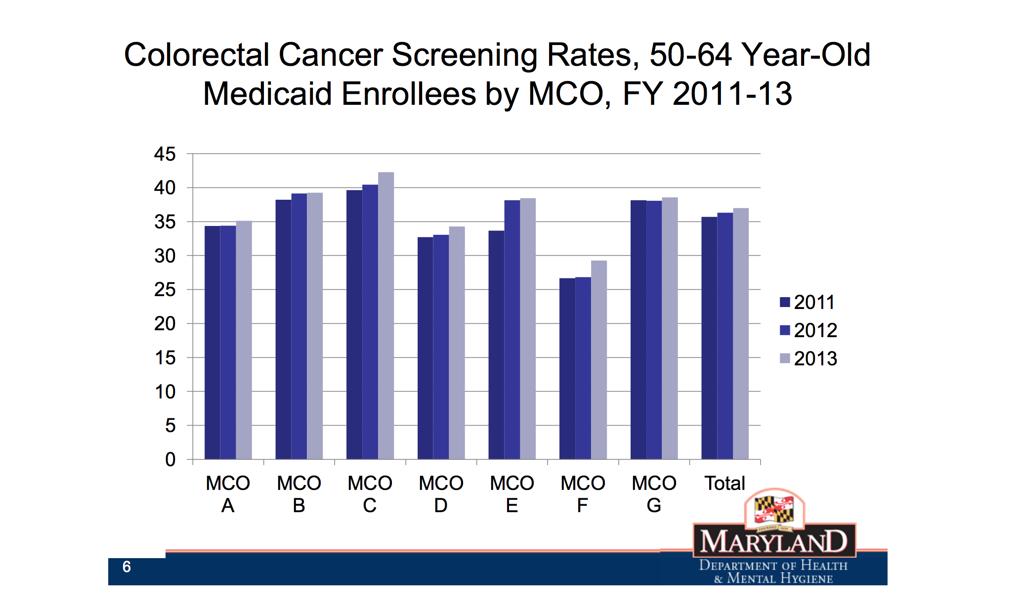
Washington
Following are statistics for state Medicaid screening rates over three years. The data include statewide Medicaid screening rates for 2012-2013 and rates from 2011-2014.
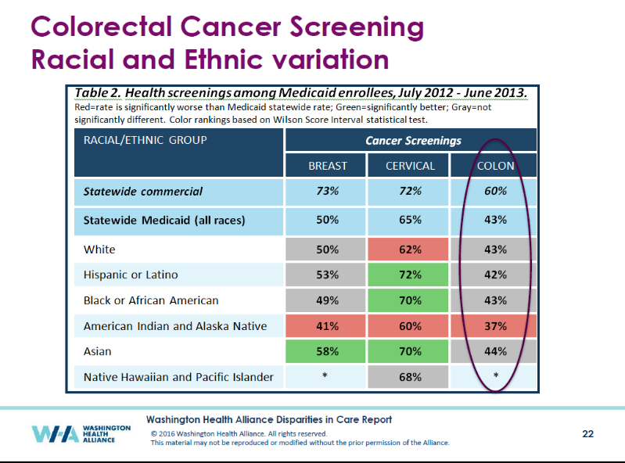

From 2013-2014, Washington State’s CRC Medicaid screening rate in Medicaid was at 44%.

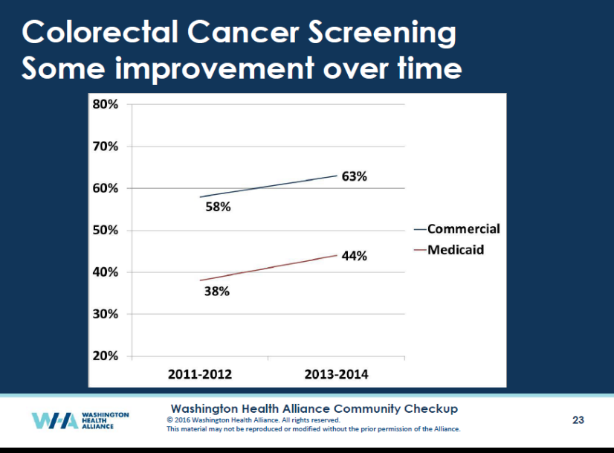

Fedewa SA, et al. How many people will need to be screened to increase Colorectal Cancer Screening Prevalence to 80% by 2018? Cancer 2015 Dec 1; 121(23):4258‐65.
Maryland Comprehensive Cancer Control Plan, Maryland Department of Health and Mental Hygiene, updated July 2011. Available at: http://phpa.dhmh.maryland.gov/cancer/cancerplan/SitePages/Home.aspx. Last accessed April 30, 2012.
Source: The Evaluation of the HealthChoice Program Report CY 2010 - CY 2014, page 33. (HealthChoice is Maryland's Medicaid managed care program, and as of the end of CY2014 covered about 81% of the state's Medicaid population) https://mmcp.dhmh.maryland.gov/Documents/HealthChoice%20Evaluation%20CY%202010%20-%20CY%202014.pdf
Ibid., 34.
Source: New HealthChoice Measures: CRC Screening and HPV Immunization Report, Medicaid Partnership with Center for Cancer Prevention and Control, July 23, 2015. (MMAC CRC-HPV Presentation 7-23-2015); page 3. ⁶ Presentation to the Washington State Roundtable, March 2016, http://www.wacancer.org/sites/default/files/CRC%20RT_Dade.pdf, slides 22-23

